**Beet Seed**

**ID:** B_001

**Environment:** Microsoft Edge v113

**Priority:** High

**Summary:**

The language switcher is not displayed in the header on the main page when Kharkiv, Mukachevo, Bukovel are selected as a city in the dropdown list

**Description**

Steps to reproduce:

1. Navigate to the main page of the Kharkiv website <https://kharkiv.oxford-med.com.ua/>
2. Look in the right corner of the header
3. Navigate to the main page of the Mukachevo website <https://mukachevo.oxford-med.com.ua/>
4. Look in the right corner of the header
5. Navigate to the main page of the Bukovel website <https://bukovel.oxford-med.com.ua/>
6. Look in the right corner of the header

**Expected result:**

The language switcher is displayed in the header on the main page when Kharkiv, Mukachevo, Bukovel are selected as a city in the dropdown list.

**Actual result:**

The language switcher is not displayed in the header on the main page when Kharkiv, Mukachevo, Bukovel are selected as a city in the dropdown list.

**Attachments:**

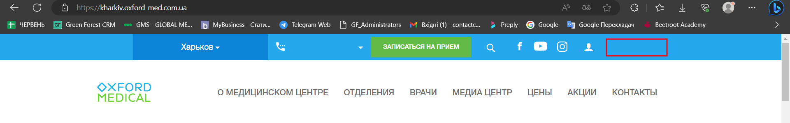

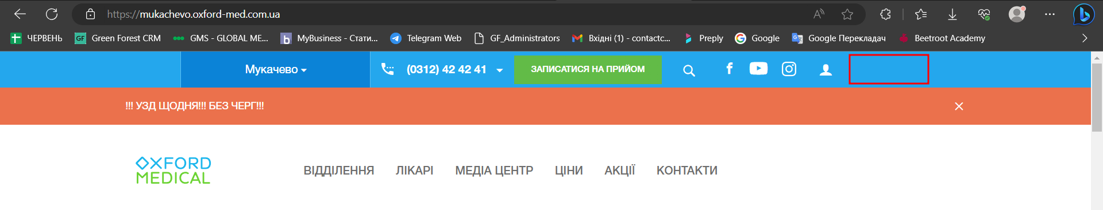

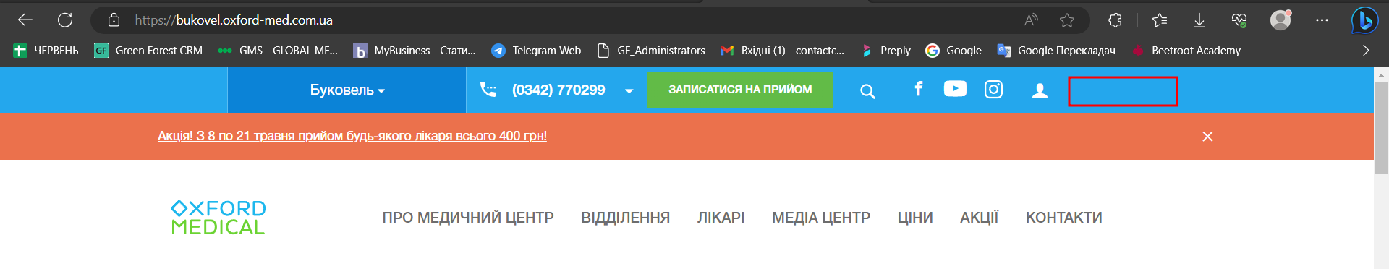

**ID:** B_002

**Environment:** Microsoft Edge v113

**Priority:** High

**Summary:**

The Message box is not displayed in the lower left corner of the main page when Bukovel is selected as a city in the dropdown list.

**Description**

Steps to reproduce:

1. Navigate to the main page of the Bukovel website <https://bukovel.oxford-med.com.ua/>
2. Look in the lower left corner

**Expected result:**

The Message box is displayed in the lower left corner of the main page when Bukovel is selected as a city in the dropdown list.

**Actual result:**

The Message box is not displayed in the lower left corner of the main page when Bukovel is selected as a city in the dropdown list.

**Attachments:**

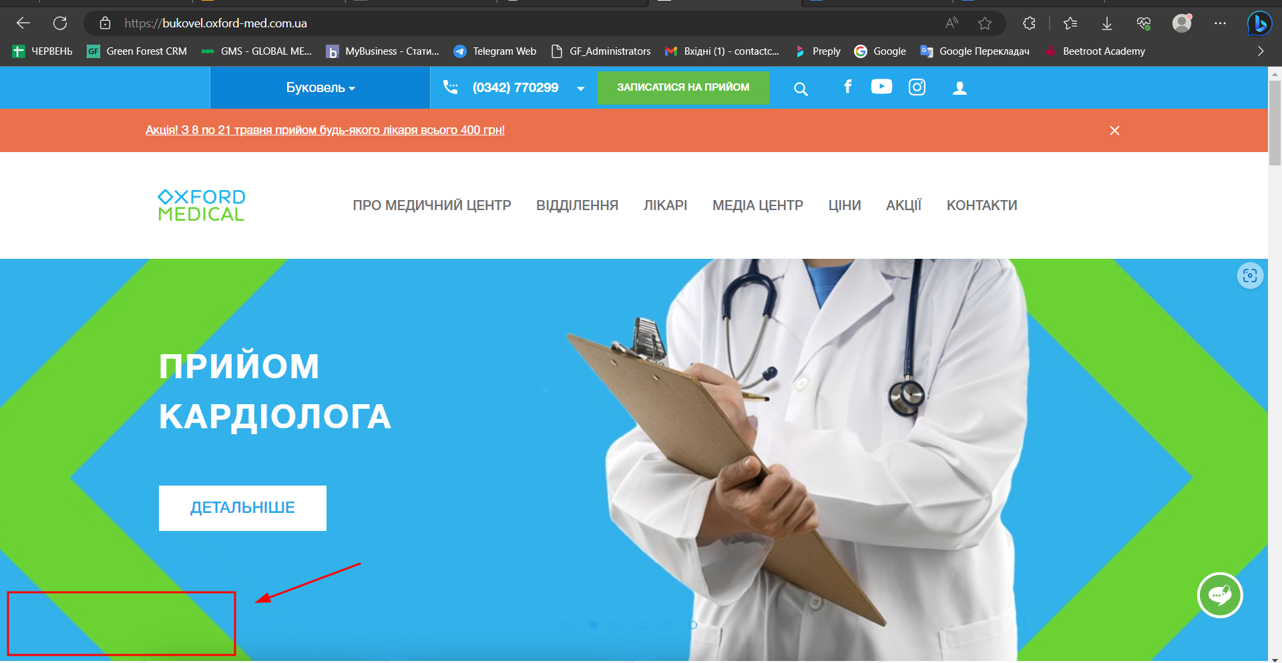

**ID:** B_003

**Environment:** Microsoft Edge v113

**Priority:** High

**Summary:**

The information about doctors is not displayed after clicking on the "Врачи" in the header when Kharkiv is selected as a city in the dropdown list.

**Description**

Steps to reproduce:

1. Navigate to the main page of the Kharkiv website <https://kharkiv.oxford-med.com.ua/>
2. Click on the “Врачи “ in the header menu
3. Scroll down the page

**Expected result:**

The information about doctors is displayed after clicking on the "Doctors" in the header when Kharkiv is selected as a city in the dropdown list.

**Actual result:**

The information about doctors is not displayed after clicking on the "Doctors" in the header when Kharkiv is selected as a city in the dropdown menu.

**Attachments:**

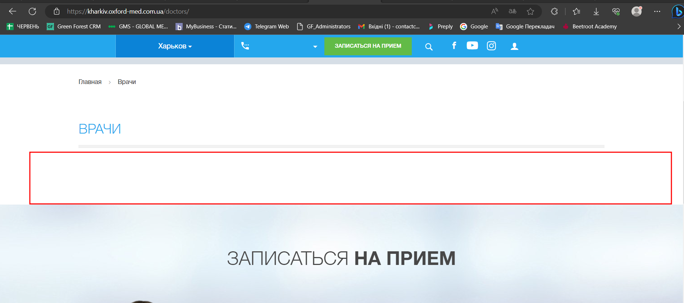

**ID:** B_004

**Environment:** Microsoft Edge v113

**Priority:** High

**Summary:**

The button "Про клініку" is not displayed on the main page after selecting the city of Mukachevo in the drop-down list.

**Description**

Steps to reproduce:

1. Navigate to the main page of the Mukachevo website <https://mukachevo.oxford-med.com.ua/>
2. Look at the info component buttons next to the logo.

**Expected result:**

The button "Про клініку" is displayed on the main page after selecting the city of Mukachevo in the drop-down list.

**Actual result:**

The button "Про клініку" is not displayed on the main page after selecting the city of Mukachevo in the drop-down list.

**Attachments:**

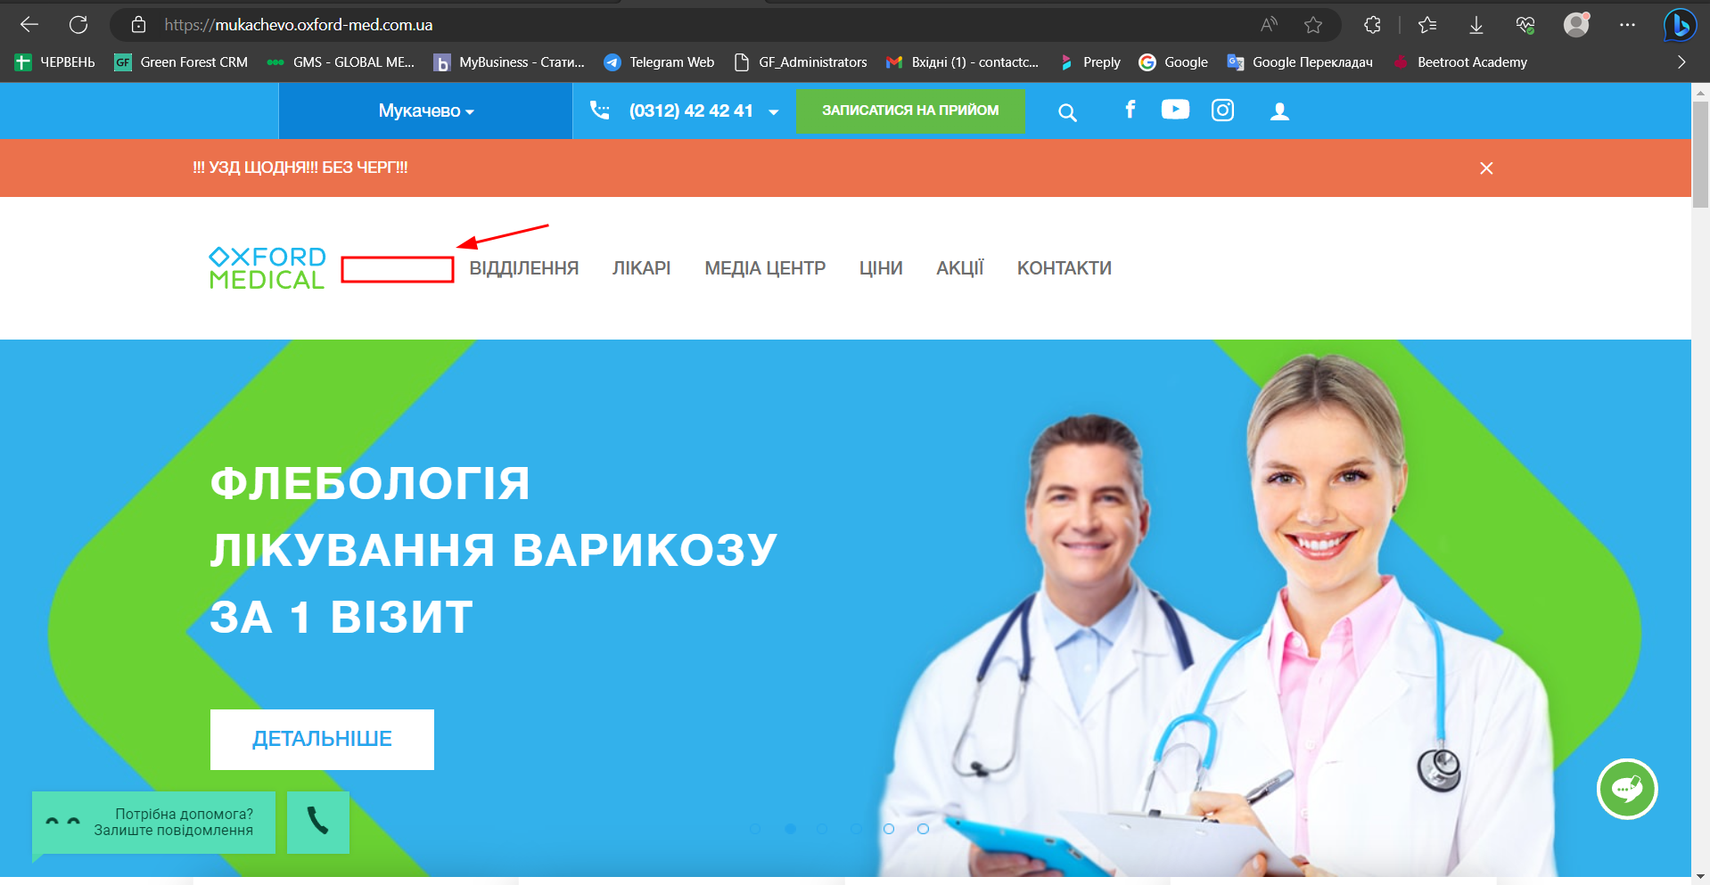

**ID:** B_005

**Environment:** Microsoft Edge v113

**Priority:** Medium

**Summary:**

The font of the information on how to get to the clinic, after clicking on the "Як дістатись " button in the “Контакти “ when Lviv is selected as a city, is different.

**Description**

Steps to reproduce:

1. Navigate to the main page of the Lviv website <https://lviv.oxford-med.com.ua/>
2. Click on the “Контакти “
3. Under the contacts of the clinic at the address ЛЬВІВ, ПР. В. ЧОРНОВОЛА, 45А/9, click on the “Як дістатися “
4. Under the contacts of the clinic at the address ЛЬВІВ, ВУЛ. ЗУБРІВСЬКА, 21, click on the “Як дістатися “
5. Look at both texts that appeared after clicking on the button “Як дістатися “

**Expected result:**

The font of the information on how to get to the clinic, after clicking on the "Як дістатись " button in the “Контакти “ when Lviv is selected as a city, is the same.

**Actual result:**

The font of the information on how to get to the clinic, after clicking on the "Як дістатись " button in the “Контакти “ when Lviv is selected as a city, is different.

**Attachments:**

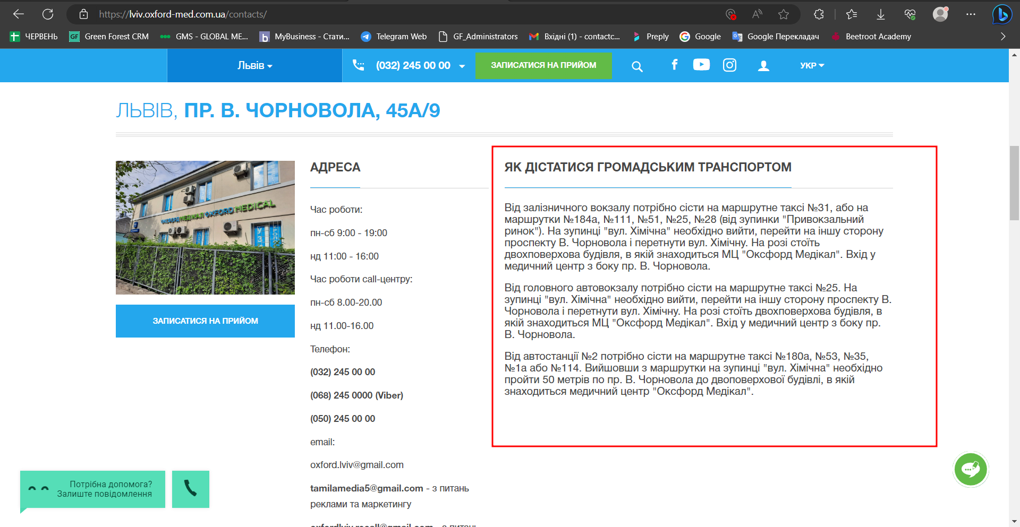

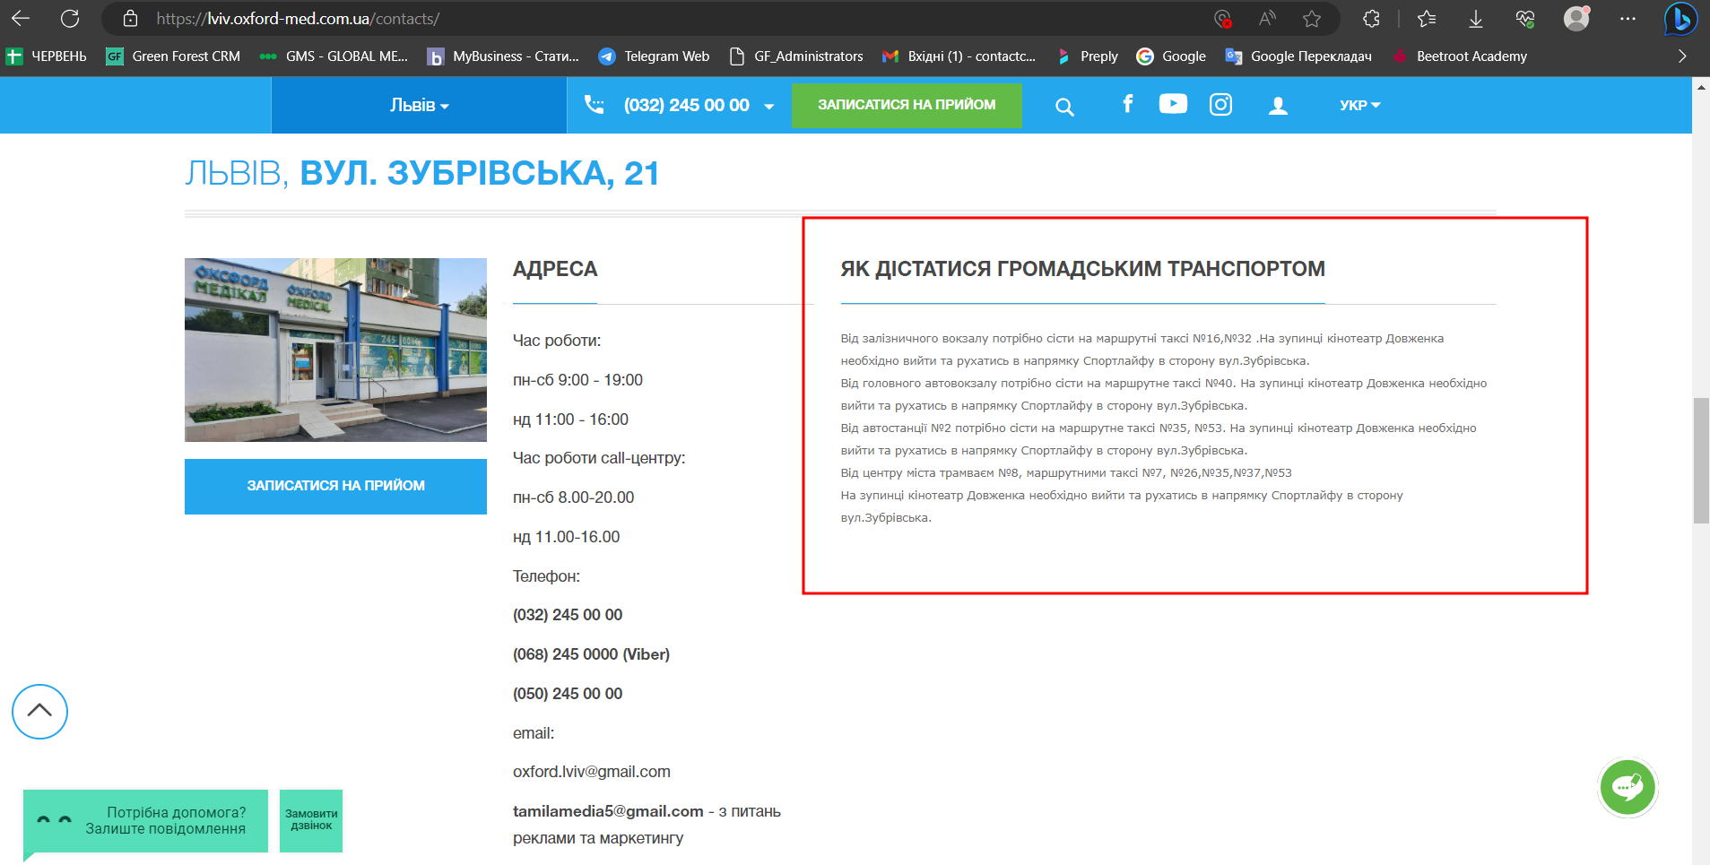

**Mighty Beet**

**2.** Провела кросбраузерне тестування знайдених раніше багів ще у Firefox v. 114.01 та Google Chrome v. 114.0.5735.110, відтворились всюди однаково.